PIZZA SALES SQL QUERIES
- KPI’s
- Total Revenue
select round(sum(total_price),2) as Total_Revenue
from pizza_sales;

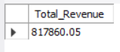
- Average Order Value
select round(sum(total_price)/count(distinct order_id),2) as Avg_Order_Value
from pizza_sales;

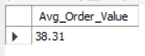
- Total Pizza Sold
select sum(quantity) as Total_Pizza_Sold
from pizza_sales;

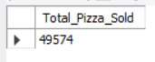
- Total Orders
select count(distinct order_id) as Total_Orders
from pizza_sales;

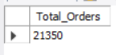
- Total Pizzas Per Order
select round(sum(quantity)*1.0/count(distinct order_id),2) as Avg_Pizzas_Per_Order
from pizza_sales;

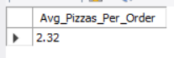

- Daily Trend for Total Orders
select dayname(order_date) as Order_Day,
count(distinct order_id) as Total_Orders from pizza_sales
group by dayname(order_date)
order by Total_Orders desc;

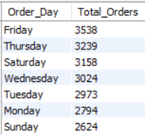

- Monthly Trend for Total Orders
select monthname(order_date) as Month_Name,
count(distinct order_id) as Total_Orders
from pizza_sales
group by monthname(order_date)
order by Total_Orders desc;

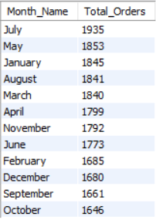

- % of Sales by Pizza Category
select pizza_category, round(sum(total_price),2) as Total_Sales,
round(sum(total_price) * 100 / (select sum(total_price) from pizza_sales),2)
as Total_Sales_Percentage
from pizza_sales
group by pizza_category;

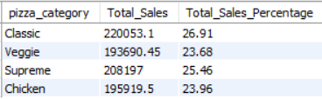

- % of Sales by Pizza Size
select pizza_size, round(sum(total_price),2) as Total_Sales,
round(sum(total_price) * 100 / (select sum(total_price) from pizza_sales),2)
as Total_Sales_Percentage
from pizza_sales
group by pizza_size;

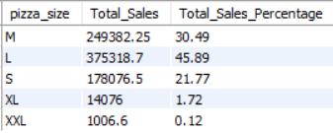

- Total Pizza Sold by Pizza Category
select pizza_category, sum(quantity) as Total_Quantity_Sold
from pizza_sales
group by pizza_category
order by Total_Quantity_Sold desc;

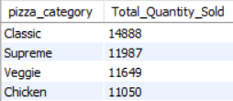

- Top 5 Pizza by Revenue
select pizza_name, sum(total_price) as Total_Revenue from pizza_sales
group by pizza_name
order by Total_Revenue desc
limit 5;

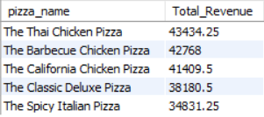

- Bottom 5 Pizza by Revenue
select pizza_name, sum(total_price) as Total_Revenue from pizza_sales
group by pizza_name
order by Total_Revenue asc
limit 5;

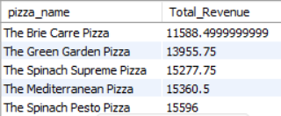

- Top 5 Pizza by Quantity
select pizza_name, sum(quantity) as Total_Quantity from pizza_sales
group by pizza_name
order by Total_Quantity desc
limit 5;

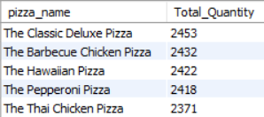

- Bottom 5 Pizza by Quantity
select pizza_name, sum(quantity) as Total_Quantity from pizza_sales
group by pizza_name
order by Total_Quantity asc
limit 5;

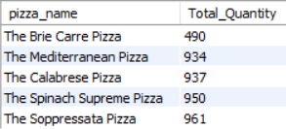

- Top 5 Pizza by Orders
select pizza_name, count(distinct order_id) as Total_Orders from pizza_sales
group by pizza_name
order by Total_Orders desc
limit 5;

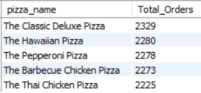

- Bottom 5 Pizza by Orders
select pizza_name, count(distinct order_id) as Total_Orders from pizza_sales
group by pizza_name
order by Total_Orders asc
limit 5;
